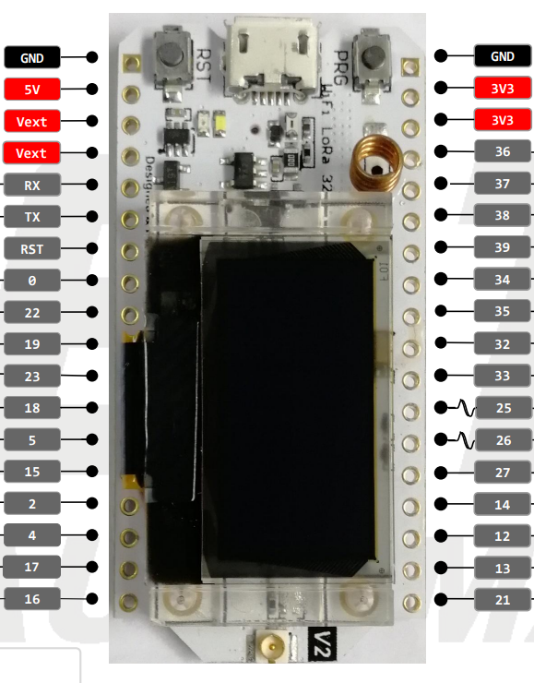

GPS TXD

SCL

SDA

SDS011 RXD

SDS011 TXD

Select Button

Down Button

UP Button